# Turnleaf CPI / ISM (GDP) vs Asset Class Returns

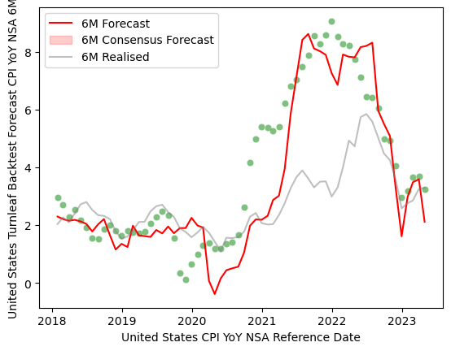

Figure 1 (from DataPrep.ipynb)

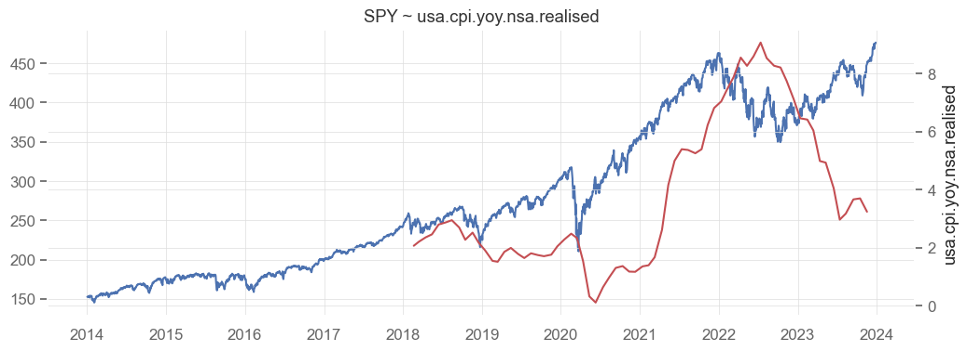

Figure 2: (from EDA.ipynb)

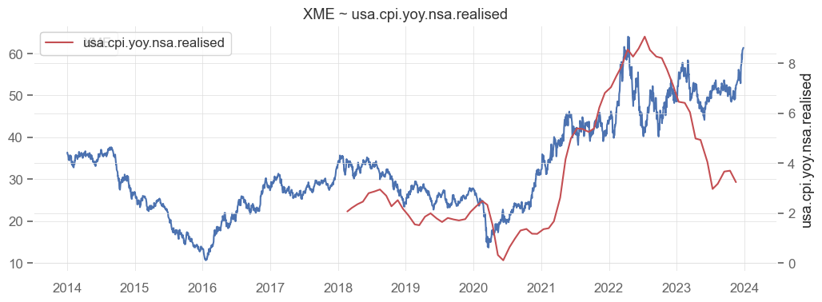

Figure 3: (from EDA.ipynb)

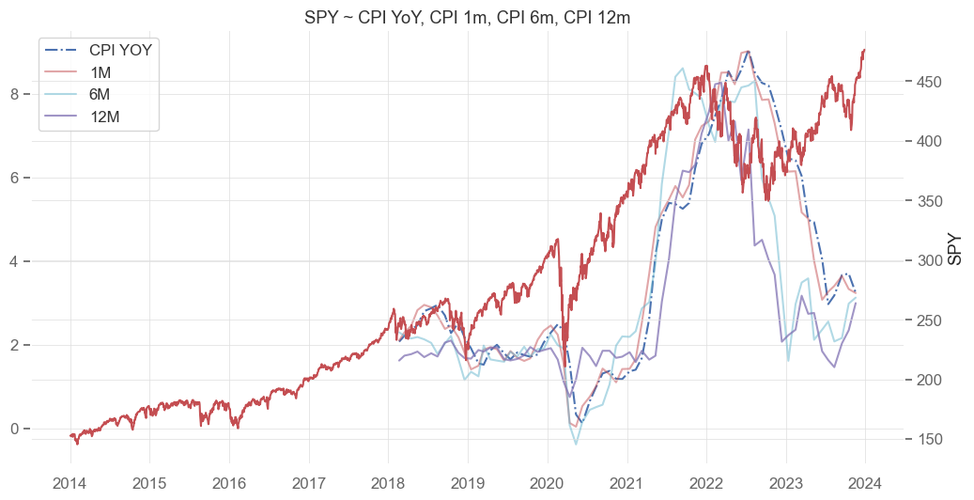

Figure 4: (from EDA.ipynb)

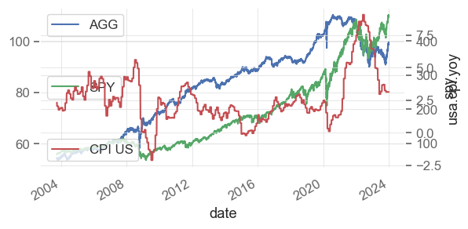

Figure 5: AGG/SPY total return vs CPI change, YoY. (from StrategyEvaluation.ipynb)

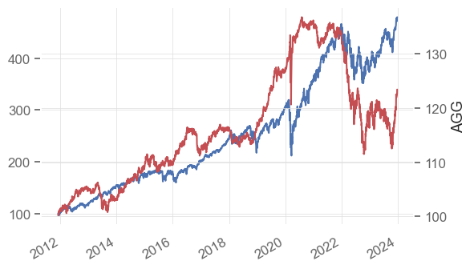

Figure 6: AGG total return vs cumulative CPI. (from StrategyEvaluation.ipynb)

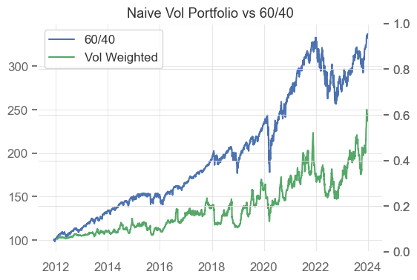

Figure 7: Total returns, Naive Vol & 60/40 portfolios. (from StrategyEvaluation)

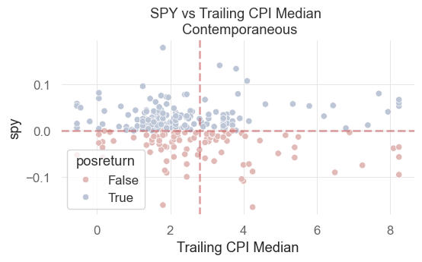

Figure 8: Monthly Returns (SPY); Above 0 signifies CPI print > trailing 12month median. (from StrategyEvaluation)

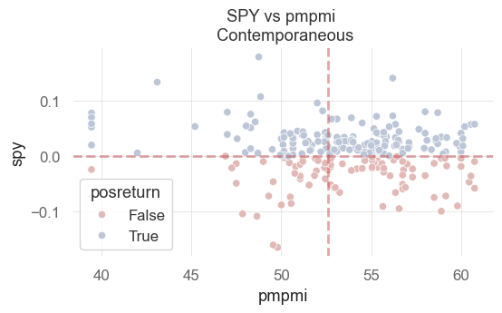

Figure 9: SPY vs ISM PMI

Returns Table

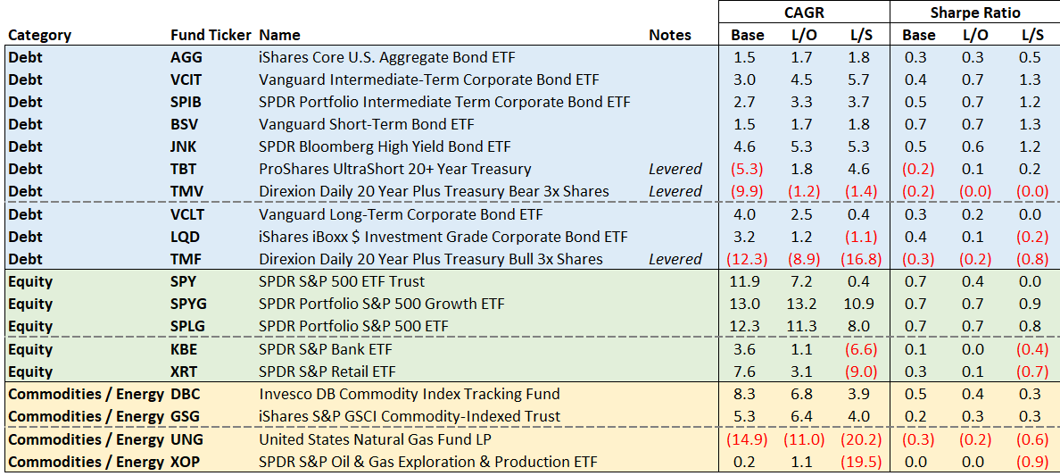

Figure 10: Returns of select ETFs, following Logistic Regression trading signal.

These results are inconsistent; note the opposite performance of TMF compared to TBT and TMV. TMF is a 3x levered etf that is long USTs. If this signal performs inversely to that of TMV and TBT, both of which are 2x and 3x levered short UST funds, then the signal itself is likely to be noise for these products.